37.69: a) Since the two triangles are similar:
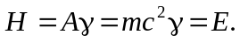
b) 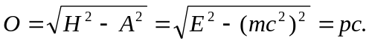
c) 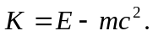
The kinetic energy can be obtained by the difference between the hypoteneuse and adjacent edge lengths.

